ARPIE RELEASE NOTES REL 5 BETA

NEW FEATURE: MANUAL CHORD INSERTION
Holding INST access the Manual Chord feature. In this mode you can manually enter a chord into the arpeggiator by toggling individual notes on and off. The layout of notes is as follows:
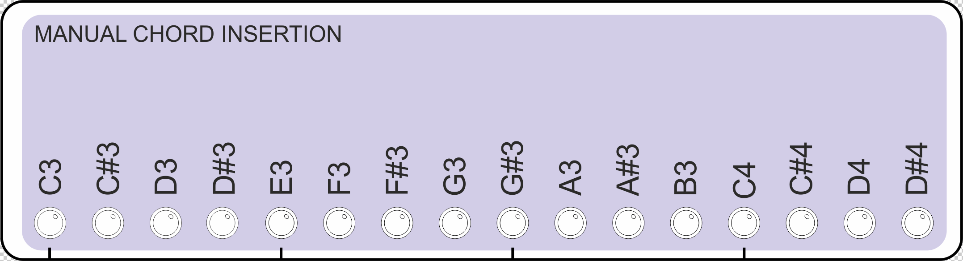
Switching any note into the chord will activate HOLD mode, clear any current chord and replace it with the selected notes

NEW FEATURE: TRANSPOSE SEQUENCE
In TRAN mode you can :
Press a single data button to transpose the sequence
Hold down TRAN and press a sequence of up to 16 data buttons (including repeated steps) to have the transpose happen automatically, based on the PLEN length (default transposes every 16 steps)

ENHANCEMENT: EXTENDED PATTERN EDIT LAYER SELECTION
A change has been made to the performance options menu (MODE button second function) so that the PATN button second function can easily be switched between five different modes
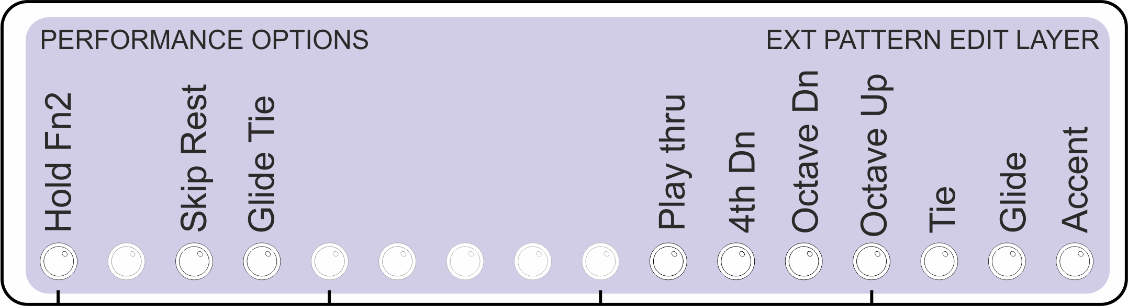

These modes determine which “layer” is shown and edited on the PATN button second function (long press on PATN button). Please note that all five layers are still always present and active and affect playback – this allows functions to be superimposed (for example Octave + Accent)

- Accent – selected step plays at full MIDI velocity – reduce the global MIDI velocity for a contrast!
- Glide – selected step plays at full step gate length but stops short of Legato (tie) – reduce the global GATE setting for a contrast!
- Tie – selected step is “tied” to the next step so the note is note ended until after the next one has started (for Legato playing effect). Takes precedence over Glide
- Octave Up – selected step is transposed up 1 octave
- Octave Dn – selected step is transposed down 1 octave
- 4th Down – selected step is transposed down 1 fourth
- Playthru – When a step with Playthru set is encountered, the note for the next step plays simultaneously with it.

A new “Randomize all Layers” (Random All on the diagram below) is added to the MODE menu which randomizes all the layers. The other three pattern fill buttons will clear all layers except for the main “play/mute” layer
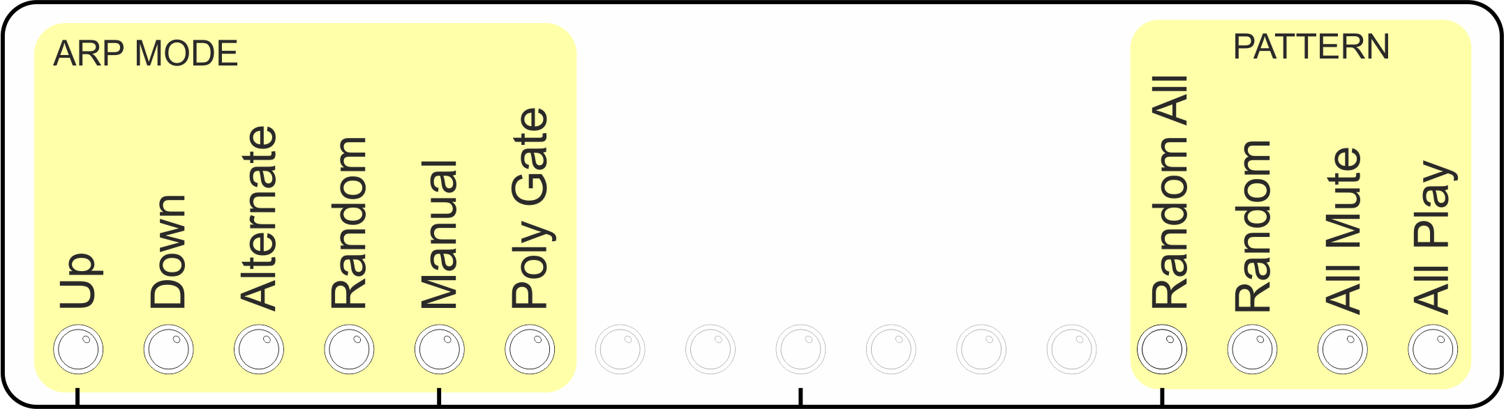

NEW FEATURE: SET ACCENT VELOCITY
Long press of the VELO button lets you set the velocity of accented notes (lights up from right hand end to avoid confusion with main velocity display)

NEW FEATURE: MANUAL START WHEN ON EXT SYNC
Previously it was necessary to wait for a MIDI “Transport Start” message before Arpie would start running when on external MIDI sync. Now there is a way to start and restart the sequence manually when synchronised to external clock
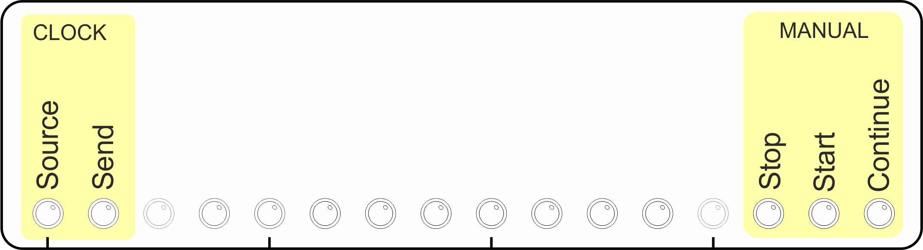

NEW FEATURES: VELOCITY CC AND LOCAL OFF
When Velocity CC mode is enabled, Arpie sends CC41 before each note to set the velocity. This is specifically aimed at users of Korg Volca FM which does not respond to MIDI velocity.

When Local Off mode is enabled, Arpie sends MIDI LOCAL OFF message on each MIDI channel at start-up time. Toggling the setting also sends LOCAL OFF or LOCAL ON messages (depending on the new value of the setting) at the time the button is pressed.

IMPROVEMENT: AUTOMATIC PASSTHRU IN “MIDI LOCK” MODE
Now in MIDI LOCK mode notes are passed from input to output allowing you to directly play connected synth etc.

BUG FIXES: PREFS RESET ON POWER RECYCLE
Some prefs were lost during power off – now fixed

